Lab assignment: 04
Problem Statement : Program to perform Insertion, Deletion, Traversal
and Searching operations on a One-Dimensional Array

Code:
def display_array(arr):
"""Function to traverse and display the array."""
if len(arr) == 0:
print("Array is empty.")
else:
print("Array elements:", arr)
def insert_element(arr):
"""Function to insert an element at a specified position."""
element = int(input("Enter element to insert: "))
position = int(input("Enter position (0 to {}): ".format(len(arr))))
if 0 <= position <= len(arr):
arr.insert(position, element)
print("Element inserted successfully.")
display_array(arr)
else:
print("Invalid position!")
def delete_element(arr):
"""Function to delete an element from a specified position."""
if len(arr) == 0:
print("Array is empty. Nothing to delete.")
return
position = int(input("Enter position to delete (0 to {}): "
.format(len(arr) - 1)))
if 0 <= position < len(arr):
deleted = arr.pop(position)
print("Deleted element:", deleted)
print("Element deleted successfully.")
display_array(arr)
else:
print("Invalid position!")
def traverse_array(arr):
"""Function to traverse the array."""
print("Array elements using traversal:")
if len(arr) == 0:
print("Array is empty.")
else:
for i in range(len(arr)):
print("Element at index", i, ":", arr[i])
def search_element(arr):
"""Function to perform linear search."""
if len(arr) == 0:
print("Array is empty.")
return

element = int(input("Enter element to search: "))
for i in range(len(arr)):
if arr[i] == element:
print("Element found at index:", i)
return
print("Element not found in the array.")
print("----- ONE-DIMENSIONAL ARRAY OPERATIONS -----")
n = int(input("Enter number of elements: "))
arr = []
for i in range(n):
element = int(input("Enter element {}: ".format(i + 1)))
arr.append(element)
print("\nInitial Array:")
display_array(arr)
while True:
print("\n----- MENU -----")
print("1. Insertion")
print("2. Deletion")
print("3. Traversal")
print("4. Searching")
print("5. Display Array")
print("6. Exit")

choice = int(input("Enter your choice: "))
if choice == 1:
insert_element(arr)
elif choice == 2:
delete_element(arr)
elif choice == 3:
traverse_array(arr)
elif choice == 4:
search_element(arr)
elif choice == 5:
display_array(arr)
elif choice == 6:
print("Program terminated.")
break
else:
print("Invalid choice! Please try again.")

Output:
Enter number of elements: 5
Enter element 1: 10
Enter element 2: 20
Enter element 3: 30
Enter element 4: 40
Enter element 5: 50

Initial Array:
Array elements: [10, 20, 30, 40, 50]
1. Insertion
2. Deletion
3. Traversal
4. Searching
5. Display Array
6. Exit
Enter your choice: 1

Enter element to insert: 25
Enter position (0 to 5): 2
Element inserted successfully.
Array elements: [10, 20, 25, 30, 40, 50]

Enter your choice: 2
Enter position to delete (0 to 5): 4
Deleted element: 40
Element deleted successfully.
Array elements: [10, 20, 25, 30, 50]

Enter your choice: 3
Array elements using traversal:
Element at index 0 : 10
Element at index 1 : 20
Element at index 2 : 25
Element at index 3 : 30
Element at index 4 : 50

Enter your choice: 4
Enter element to search: 30
Element found at index: 3
Theory :
A one-dimensional array is a linear data structure that stores a collection of elements of the same data type in contiguous memory locations. Each element in an array can be accessed using its index value. Arrays allow various operations such as insertion, deletion, traversal, and searching.
1. Insertion Operation Insertion is the process of adding a new element at a specified position in an array. To insert an element, the existing elements after that position are shifted one position towards the right.
2. Deletion Operation Deletion removes an element from a specified position in an array. After deletion, the remaining elements are shifted towards the left to fill the empty space.
3. Traversal Operation Traversal is the process of accessing and displaying each element of an array one by one.
4. Searching Operation Searching is used to find the location of a specific element in an array. Linear Search is commonly used for unsorted arrays, where each element is checked sequentially.
Algorithm
Start.
2. Create an empty array.
3. Read the elements and store them in the array.
- 4. For Insertion:
- • Start. • Read the array. • Read the element to be inserted. • Read the position. • Check whether the position is valid. • Insert the element at the specified position. • Display the updated array. • Stop.

- 5. For Deletion: • Start. • Read the array. • Read the position of the element to be deleted. • Check whether the position is valid. • Delete the element. • Display the updated array. • Stop.

- ‘6. For Traversal: • Start. • Read the array. • Set i = 0. • Repeat until i < n. • Display A[i]. • Increment i. • Stop.

- 7. For Searching: • Start. • Read the array. • Set i = 0. • Repeat until i < n. • Display A[i]. • Increment i. • Stop.

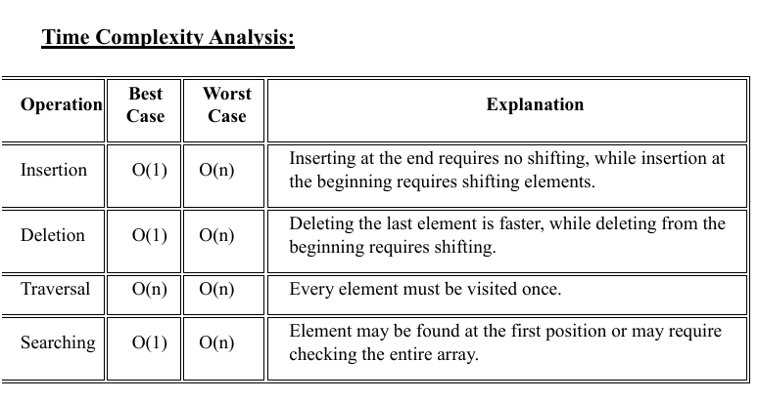
- Space Complexity: • The space complexity of storing elements in an array is O(n). • Extra me

Conclusion: Thus, the Python program to perform insertion, deletion, traversal, and searching operations on a one-dimensional array was successfully implemented. The time complexity of each operation was analyzed and understood. mory used during operations is O(1).

